# Software Requirements

Version 1.0.2, last updated by Hanfeng Zhang at 2020-09-18

# Software Requirements Specification (SRS)

Revision History:

|  |  |  |
| --- | --- | --- |
| Date | Author | Description |
| 2020-09-18 | Hanfeng Zhang | Writing(use case part), use case graph & Gantt graph added. |
| 2020-09-18 | Chenkai Ma | Writing |
|  |  |  |
|  |  |  |

Contents

Software Requirements 1

Software Requirements Specification (SRS) 1

1.  Introduction 3

1.1    Intended Audience and Purpose 3

2.  Concept of Operations 3

2.1    System Context 3

2.2    System capabilities 4

3.  Use Cases 4

3.1 System Inputs and Outputs 6

3.1.1 Inputs 6

3.1.2 Outputs 6

3.2 Detailed Output Behavior 6

4   Quality Requirements 7

5.    Fundamental Assumptions 7

6.    Expected Changes 7

## 1.  Introduction

### 1.1    Intended Audience and Purpose

This document is intended to provide information guiding the installation and development process, ensuring that all system requirements are met. The following entities may find the document useful:

Client Teams & Server Team - The Client Teams and the Server Team will be able to use this document to identify the main functionality included in the algorithm. Furthermore, the algorithm will have a set of system requirements before it can be run. Details regarding these requirements can be found here.

Coders - Details of specific requirements that the final software build must include will be located here. Coders can use this document to ensure the software addresses each of these requirements.

Testers - By developing testing procedures founded in the system requirements, the testers can create a comprehensive testing regimen that will guarantee requirements are met.

Estimated Gantt Graph:

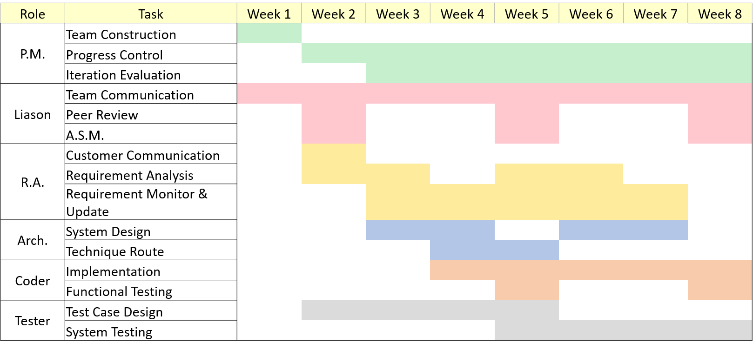

## 2.  Concept of Operations

The aim is to write an excellent artificial intelligence algorithm for processing images of scoliosis. This algorithm will read a picture and output the analysis results. Other programs calling this program should ensure the format and quantity of input content. At the same time, they should also meet the interface provided by this program.

### 2.1    System Context

**System Requirements:**

Requires a system with a GUI display because all of the operations are performed through a GUI. The application is in C++ so users must have an updated version of C++ installed on their machine to use the application.

Windows:

* Windows 10 (8u51 and above)
* Windows 8.x (Desktop)
* Windows 7 SP1
* Windows Vista SP2
* Windows Server 2008 R2 SP1 (64-bit)
* Windows Server 2012 and 2012 R2 (64-bit)
* RAM: 1G (Minimum)
* Disk space: 4G (Minimum, for data and others)
* Processor: Minimum Pentium 2 266 MHz processor

Android:

* SDK: API 4 (Minimum)

### 2.2    System capabilities

Call this program, one can get the processing results of the picture. This program will give guidance information on whether the picture belongs to scoliosis, the type of scoliosis, the angle of scoliosis, and other useful information.

## 3.  Use Cases

**Figure 1. The use case diagram**

The use case diagram is shown in Figure 1 above. The detailed information is explained below:

Case 1: User wants to scan the X-Ray photograph

Players: End User

Goals: The end user wants to scan the X-Ray photograph.

Preconditions: The application is working.

Case:

1.1 From the File menu, the end user selects the “Scan X-Ray photograph”.

1.2 The application instructs the user to put X-Ray photograph in the scanner.

1.3 The application gets the image of X-Ray photograph in digital version from the scanner.

Alternative Flows:

1.2.1 The scanner is currently unavailable.

1.2.1.1 The application returns with error and report it to the user.

1.3.1 The scanner returns no image.

1.3.1.1 The application returns with error and report it to the user.

Postconditions:

The application now opens a digital image corresponding to the X-Ray photograph. And it is ready for further operations.

Case 2: User wants to do an angle calculation

Players: End User

Goals: The end user wants to do an angle calculation.

Preconditions: The application is working and a digital X-Ray image is available.

Case:

2.1 From the Operation menu, the end user selects the “Angle Calculation”.

2.2 The application extracts lines of bones from the image.

2.3 User selects two of the bones.

2.4 The application calculates the angle of them and return the value to the user.

Alternative Flows:

2.1.1 The user does the operation without available digital image.

2.1.1.1 The application returns with error and report it to the user.

2.2.1 The application cannot identify any bones from the image.

2.2.1.1 The application returns with error and report it to the user.

2.4.1 Fewer or more than two bones are selected.

2.4.1.1 The application returns with error and report it to the user.

Postconditions:

The user gets the angle of two selected bones from the X-Ray image.

Case 3: User wants to classify the case of scoliosis.

Players: End User

Goals: The end user wants to classify the case of scoliosis.

Preconditions: The application is working and a digital X-Ray image is available.

Case:

3.1 From the Operation menu, the end user selects the “Scoliosis Classification”.

3.2 The application processes the image with implemented algorithms, including calculates angle of every two bones.

3.3 The application tells the user whether this case is “C”, “S” or normal shape.

Alternative Flows:

3.1.1 The user does the operation without available digital image.\

3.1.1.1 The application returns with error and report it to the user.

Postconditions:

The user is now aware of the classification of scoliosis in this case.

Case 4: User wants to migrate the model.

Players: End User

Goals: The end user wants to migrate the model.

Preconditions: The application is working and a digital X-Ray image is available.

Case:

4.1 From the Operation menu, the end user selects the “Model Migration”.

4.2 The application extracts the model of this case and output to a file.

Alternative Flows:

4.1.1 The user does the operation without available digital image.

4.1.1.1 The application returns with error and report it to the user.

Postconditions:

The user gets the model file of this case.

Case 5: User wants to compare the results with other algorithms.

Players: End User

Goals: The end user wants to compare the results with other algorithms.

Preconditions: The application is working and a digital X-Ray image is available.

Case:

5.1 From the Operation menu, the end user toggle at least of one algorithms to compare with.

5.2 The application apply the operation using selected algorithms and return their result to the user.

Alternative Flows:

5.1.1 The user does the operation without available digital image.

5.1.1.1 The application returns with error and report it to the user.

Postconditions:

The user gets the results from other algorithms.

### 3.1 System Inputs and Outputs

### 3.1.1 Inputs

The input to this program comes from the programs of other groups. Other programs can input pictures to get relevant information. The input image should meet the format and size requirements. At the same time, although the program will have a good enough running speed, it should avoid calling a copy of the program too frequently. Different copies of this program can run on multiple servers. Therefore, the server should balance the load correctly and reasonably.

### 3.1.2 Outputs

The output of this program is a series of preset limited tokens. These tokens will contain different information about scoliosis. The caller of this program shall ensure the use of the token set and semantic set suitable for this program. Although this program will ensure a high enough accuracy, the caller should also be clear that such accuracy cannot always be 100%. Therefore, the caller should make the necessary prompt in a reasonable way when presenting the information to the customer.

### 3.2 Detailed Output Behavior

The output of this program will be string type and integer type. The caller of this program must be able to receive these data types correctly. Since different string or integer tokens have different meanings, the caller of this program must actively and forwardly communicate with this team to ensure the correct interpretation of these tokens.

## 4   Quality Requirements

The program must be competitive with other programs which are made by Team A2 and Team A3 in regard to performance, reliability, consistency, and scalability.

Since the problems involved in this program are relatively new, the requirements of this program are mainly for reference.

Performance: Responsiveness to user input

 * Standard actions that should not exceed 10000ms execution time.

## 5.    Fundamental Assumptions

The caller of this program will meet all the hardware requirements of this program.

The caller of this program uses the same token and semantic system as this program.

The caller of this program will input the correct format and size of the picture.

The training set of this program is known.

## 6.    Expected Changes

Future Platforms:

IOS system  
performance requirements

Languages